INSTRUCTIONS ON USING SELF-SERVICE TO SEARCH FOR UNIVERSITY CLASSES
(1a) Go to https://selfservice.fdu.edu/student/courses or

(1b) use your favorite search engine to search for: FDU Self-Service catalog or

(1c) go to www.fdu.edu and then use “Shortcuts” to select Self-Service and then click the bottom square which says “Course Catalog)

(2) Select Fall 2023 (or whatever term, just don't choose Vancouver)

(3) select Subject(s) OR just leave blank if you want a (long!) listing of all courses offered

(4) Select location (make sure you pick Florham Campus)

(5) Select Search (blue button at the bottom of the screen)

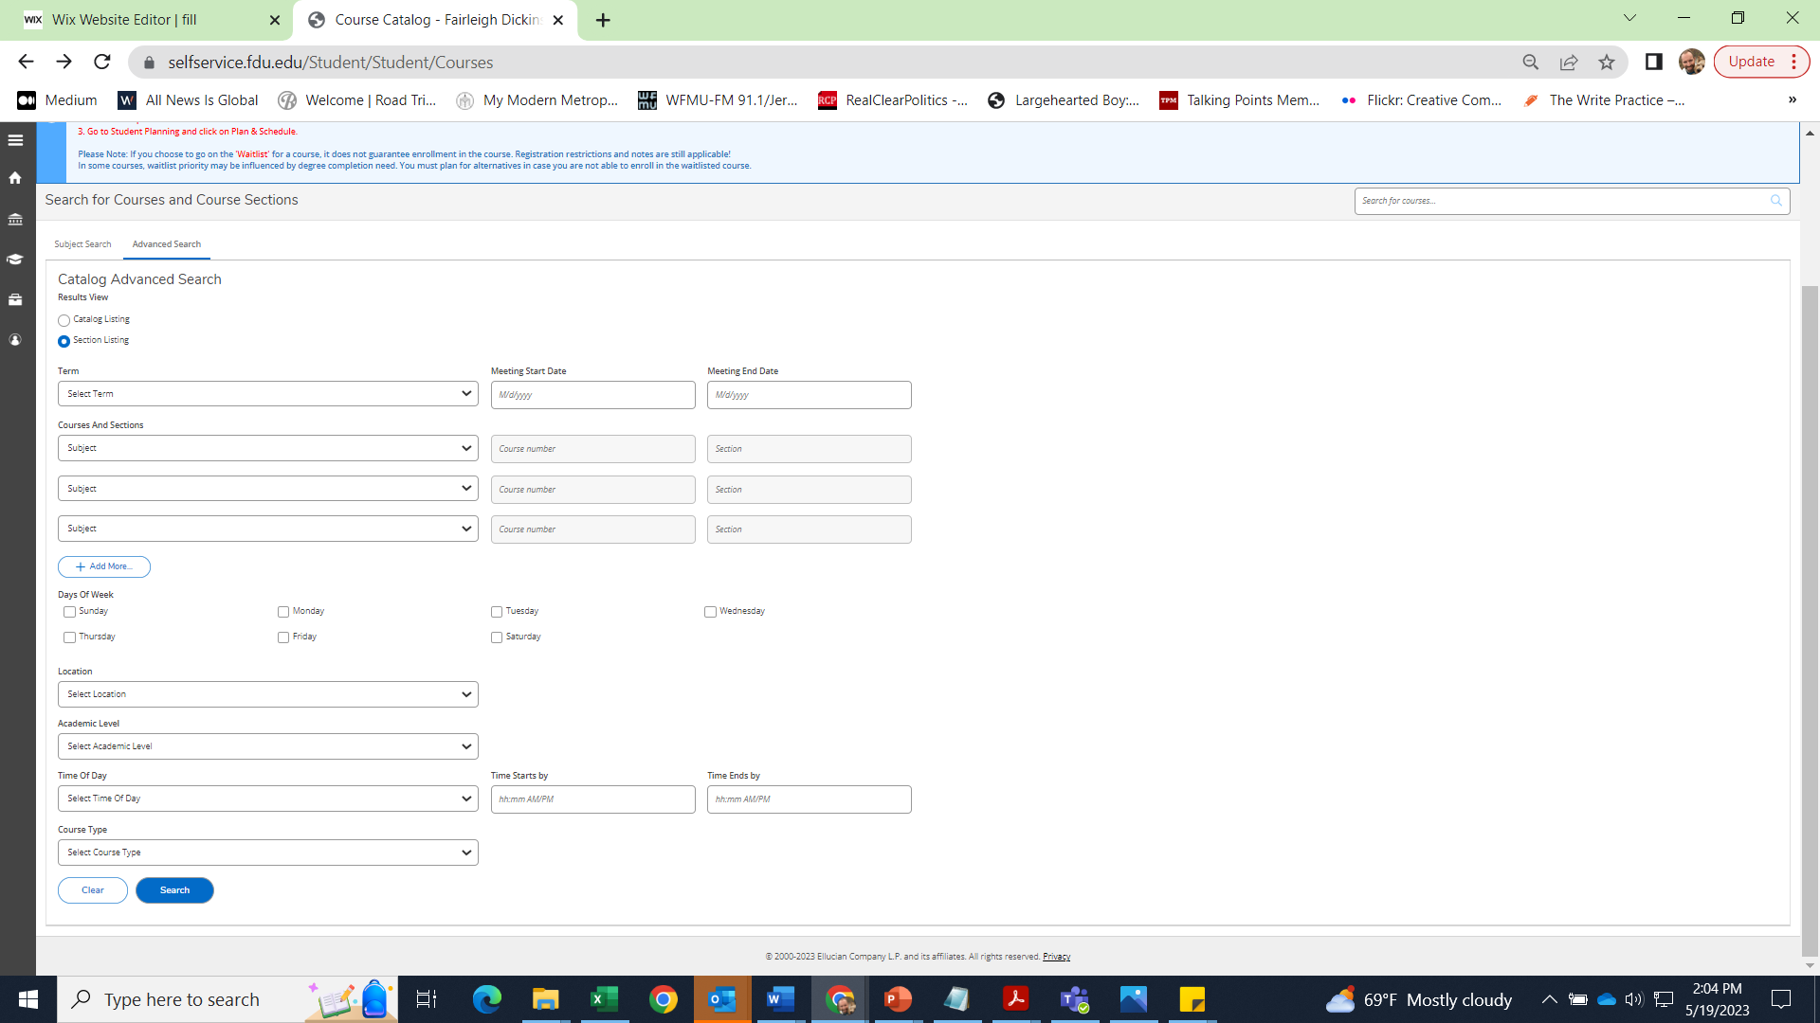
(6) You can then further refine this search using the options on the left side of the page (such as: Open Sections Only; Days of the Week; Instructor; Online only)
When you are happy with your choices, click on “Search” and your course selections will appear; NOTE: there may be more than one page of selections; check the bottom of the page
Select Florham Campus
Select the subject(s) you are interested in (for example, HIST for History)
Select the term you are interested in (for example, Fall 2023)

INSTRUCTIONS ON USING SELF SERVICE TO PAY YOUR BILLS
To access your eBill, please log into your Self-Service account using your FDU NetID and password (You may also need Duo Mobile installed on your phone)

You can also reach Self Service by going to www.fdu.edu and then use “Shortcuts” to select Self Service and then click the top square which says “Self-Service Login”). Once logged in, click on 'Student Finance' and it will bring you to the 'Account Summary' section.
Click 'Account Activity' and you will see 'View Statement' on the right side.
Once you select 'View Statement', a PDF version of the term statement you selected will open and you will have the option to download or print.
To submit payment, please click on 'Payments/Payment Plans/1098T' in the 'Financial Information' section.

ALTERNATIVELY…You may be able to pay by going to the “Make a Payment” hyperlink next to “Total Amount Due” which will then take you to the Continue to Payment Center

PAY BY MAIL INSTRUCTIONS
You can send a check for $280 made payable to FDU or “Fairleigh Dickinson University” to:
John Pasqua, Associate Director of Enrollment Services
FDU, M-MS0-04
285 Madison Avenue
Madison, NJ 07940

