To locate an instructor’s email.
Locate the class you want to take in the course catalog.
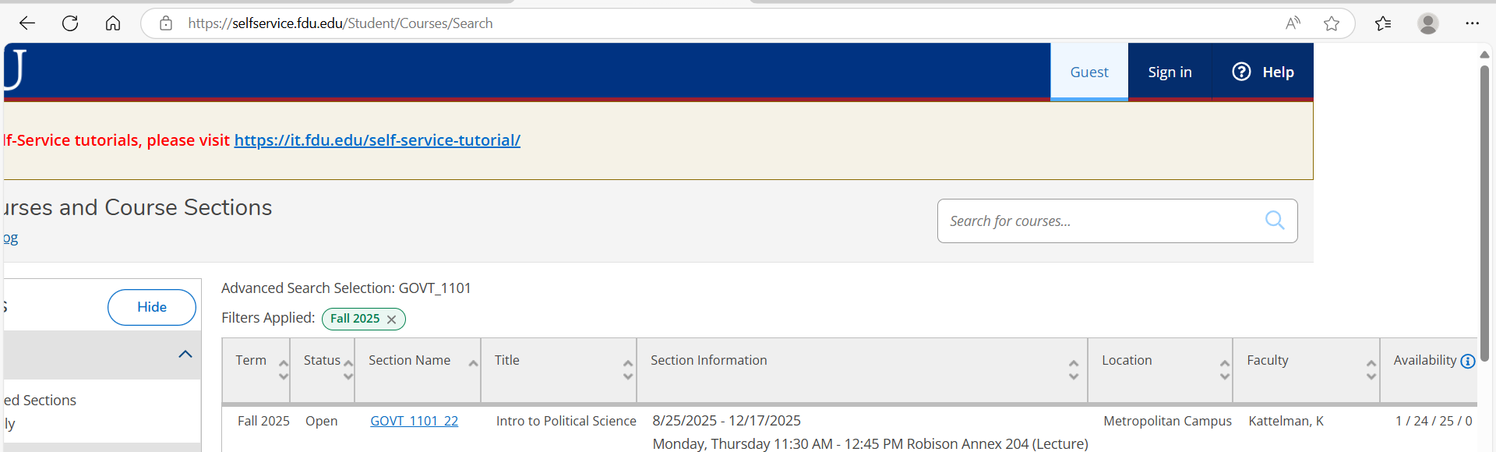

Then scroll to the right to see the instructor information.
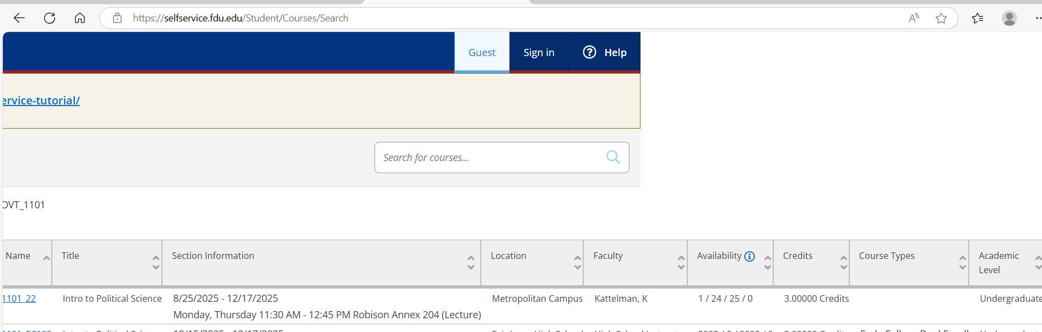
Enter the instructor’s name into the directory, Faculty and Staff Directory | Fairleigh Dickinson University.
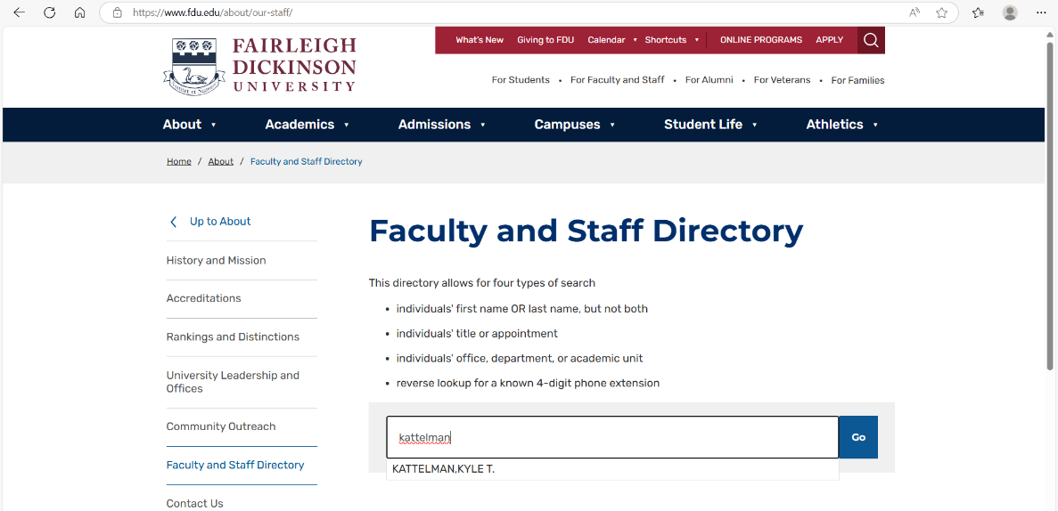
Choose the name that matches the instructor name or press GO.
