INSTRUCTIONS ON USING SELF-SERVICE TO SEARCH FOR UNIVERSITY CLASSES
(1a) Go to https://selfservice.fdu.edu/student/courses or

(1b) use your favorite search engine to search for: FDU Self-Service catalog or

(1c) go to www.fdu.edu and then use “Shortcuts” to select Self-Service and then click the bottom square which says “Course Catalog)

(2) Select Fall 2025 (or whatever term, just don't choose Vancouver)

(3) select Subject(s) OR just leave blank if you want a (long!) listing of all courses offered

(4) Select location (make sure you pick Metro Campus)

(5) Select Search (blue button at the bottom of the screen)

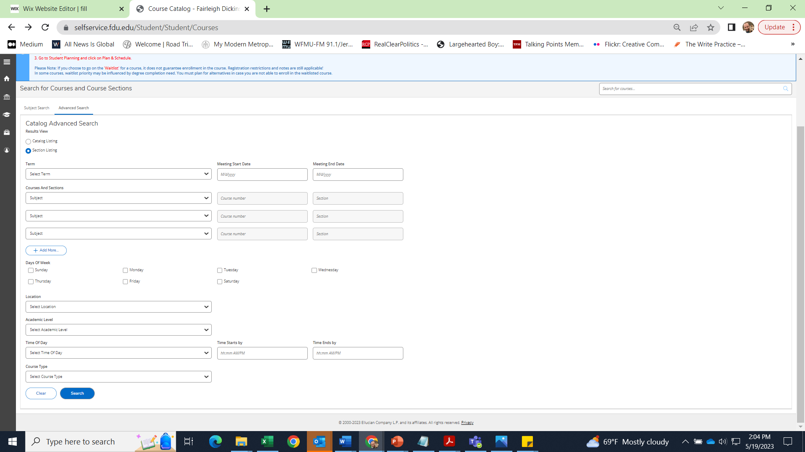
(6) You can then further refine this search using the options on the left side of the page (such as: Open Sections Only; Days of the Week; Instructor; Online only)
When you are happy with your choices, click on “Search” and your course selections will appear; NOTE: there may be more than one page of selections; check the bottom of the page
Select Metro Campus
Select the subject(s) you are interested in (for example, HIST for History)
Select the term you are interested in (for example, Fall 2023)

